**Linux**

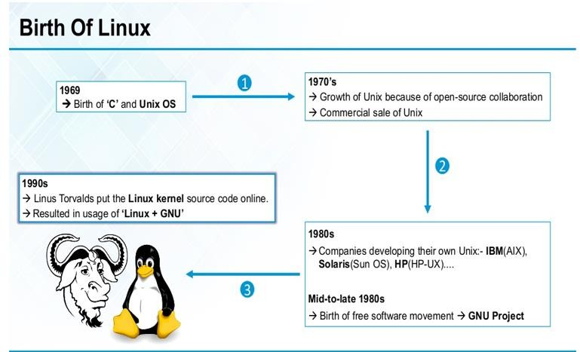**Linux** is the most important operating system in Networking World. Many Network Engineers, Network Administrators and Network Technicians use **Linux** in different areas of Computer Networking.



Linux is an Open-source Unix ilke Operating System. It is based on Linux Kernel. This Linux kernel was firstly released by Linus Torvalds at 17 September 1991. There are different distributions of Linux, some of these are:

* **Red Hat**
* **Ubuntu**
* **Fedora**
* **Debian**
* **Suse etc.**

All these **Linux versions** uses the same **Linux commands** and all the **Basic Linux commands** are similar in these Operating Systems.

KERNEL :

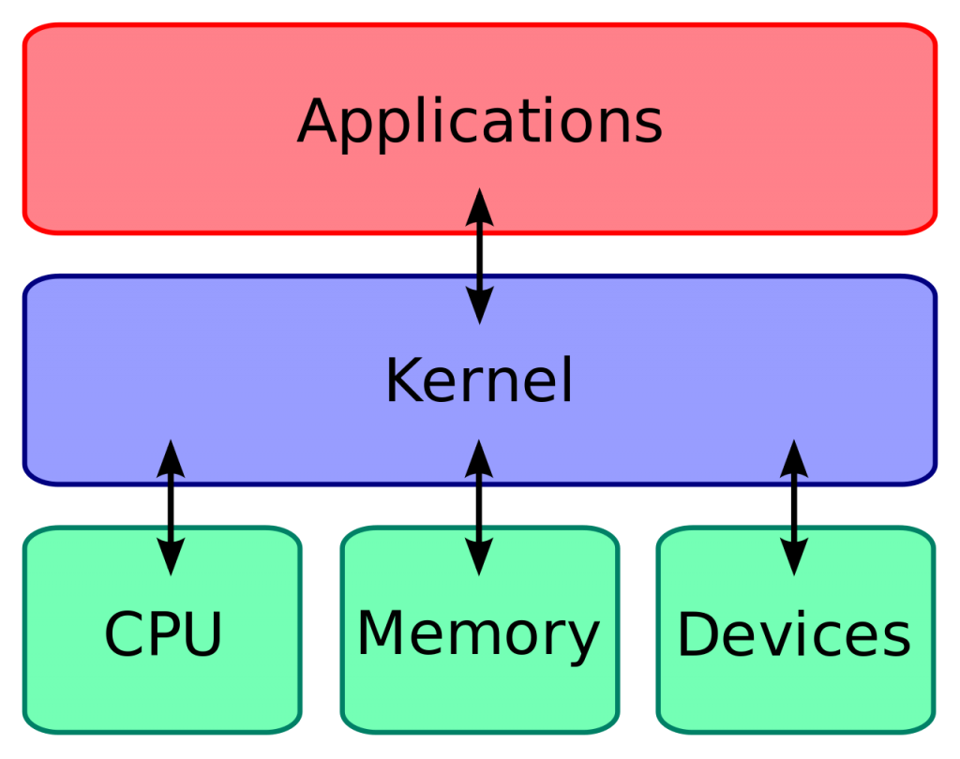

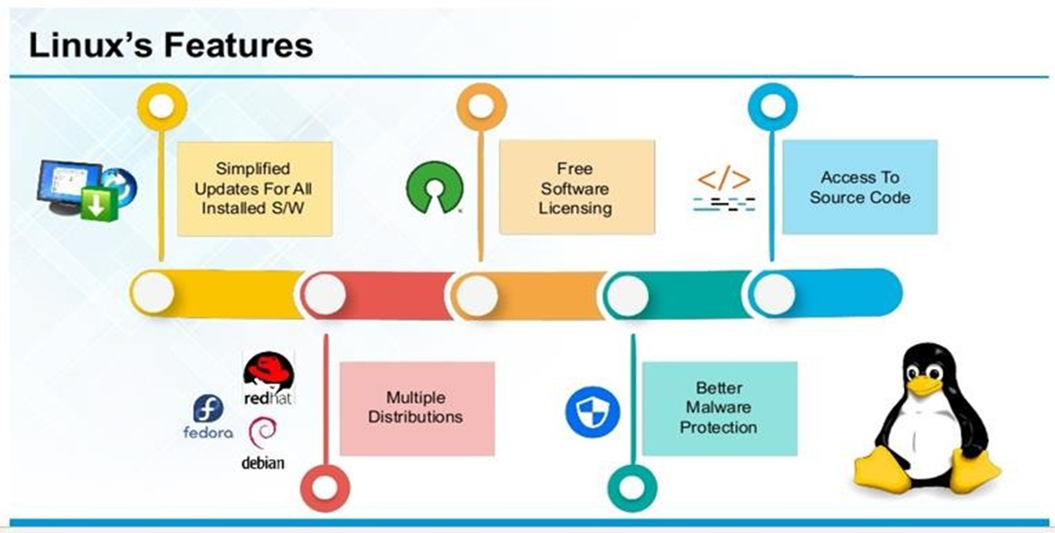

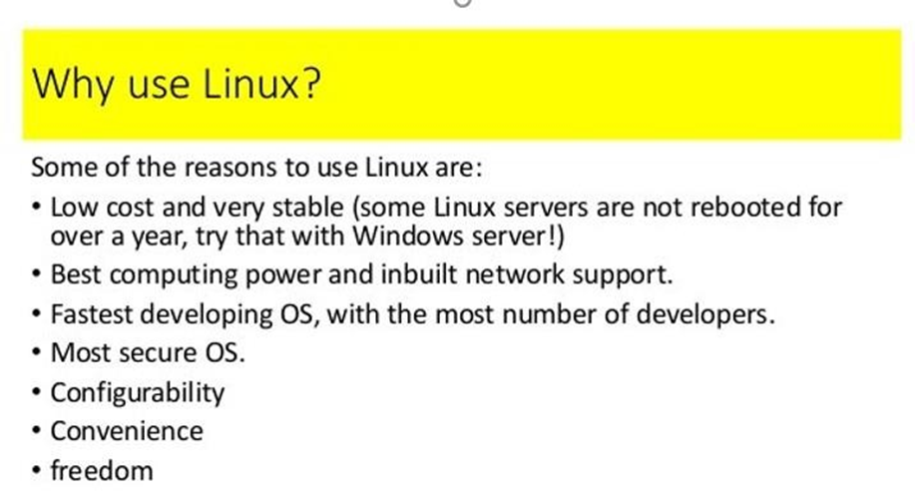

**To Open terminal --> Ctrl + Alt + T**

**Command Usability**

hostname Display hostname of the system.

hostname -f Displays Fully Qualified Domain Name (FQDN) of the system

passwd Change password of current user.

Whoami Username of the users logged in at the terminal

who List of all the users currently logged in as a user

w Display current system status, time, duration, list of users currently logged in on system and other user information.

last Who recently used the system.

last root When was the last time root logged in as user.

File Commands

1. ls Directory listing

2. ls -al Formatted listing with hidden files

3. ls -lt Sorting the Formatted listing by time modification

4. cd dir Change directory to dir

5. cd Change to home directory

6. pwd Show current working directory

7. mkdir dir Creating a directory dir

8. cat >file Places the standard input into the file

9. more file Output the contents of the file

10. head file Output the first 10 lines of the file

11. tail file Output the last 10 lines of the file

12. tail -f file Output the contents of file as it grows,starting with

the last 10 lines

13. touch file Create or update file

14. rm file Deleting the file

15. rm -r dir Deleting the directory

16. rm -f file Force to remove the file

17. rm -rf dir Force to remove the directory dir

18. cp file1 file2 Copy the contents of file1 to file2

19. cp -r dir1 dir2 Copy dir1 to dir2;create dir2 if not present

20. mv file1 file2 Rename or move file1 to file2,if file2 is an existing

directory

21. ln -s file link Create symbolic link link to file

: